Lab 1



EE 442 4/6/16

Jake Garrison (1126716)

Jisoo Jung(???????)

# Problem 1

## Results

## C:\Users\Jake\Desktop\443\Labs\Lab_1\q1-800hz.jpg

Figure Demonstrates our sine wave outputted by the dac is indeed ~800 Hz

# Problem 2

Explain setup and code structure

## 3k Hz Tone Result

Explain reuslts

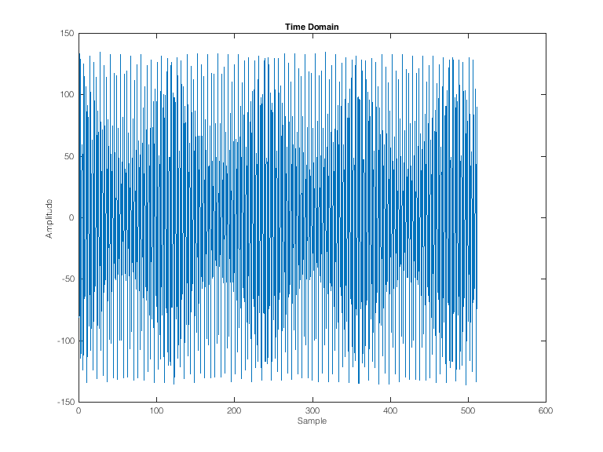

Figure Time domain representation of the 3k hz input sent over uart

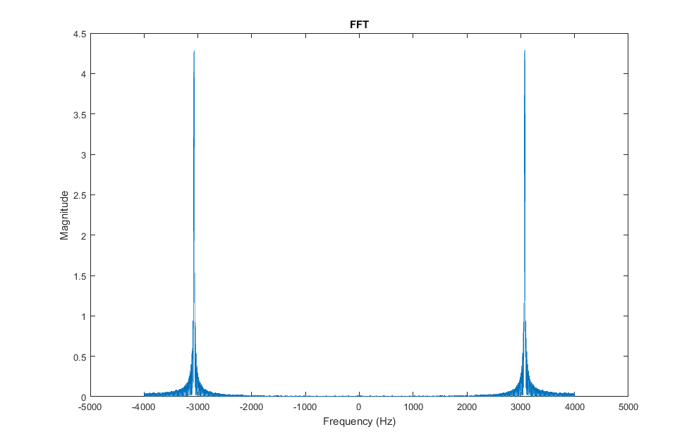

Figure FFT results of 3k hz input signal sent over uart

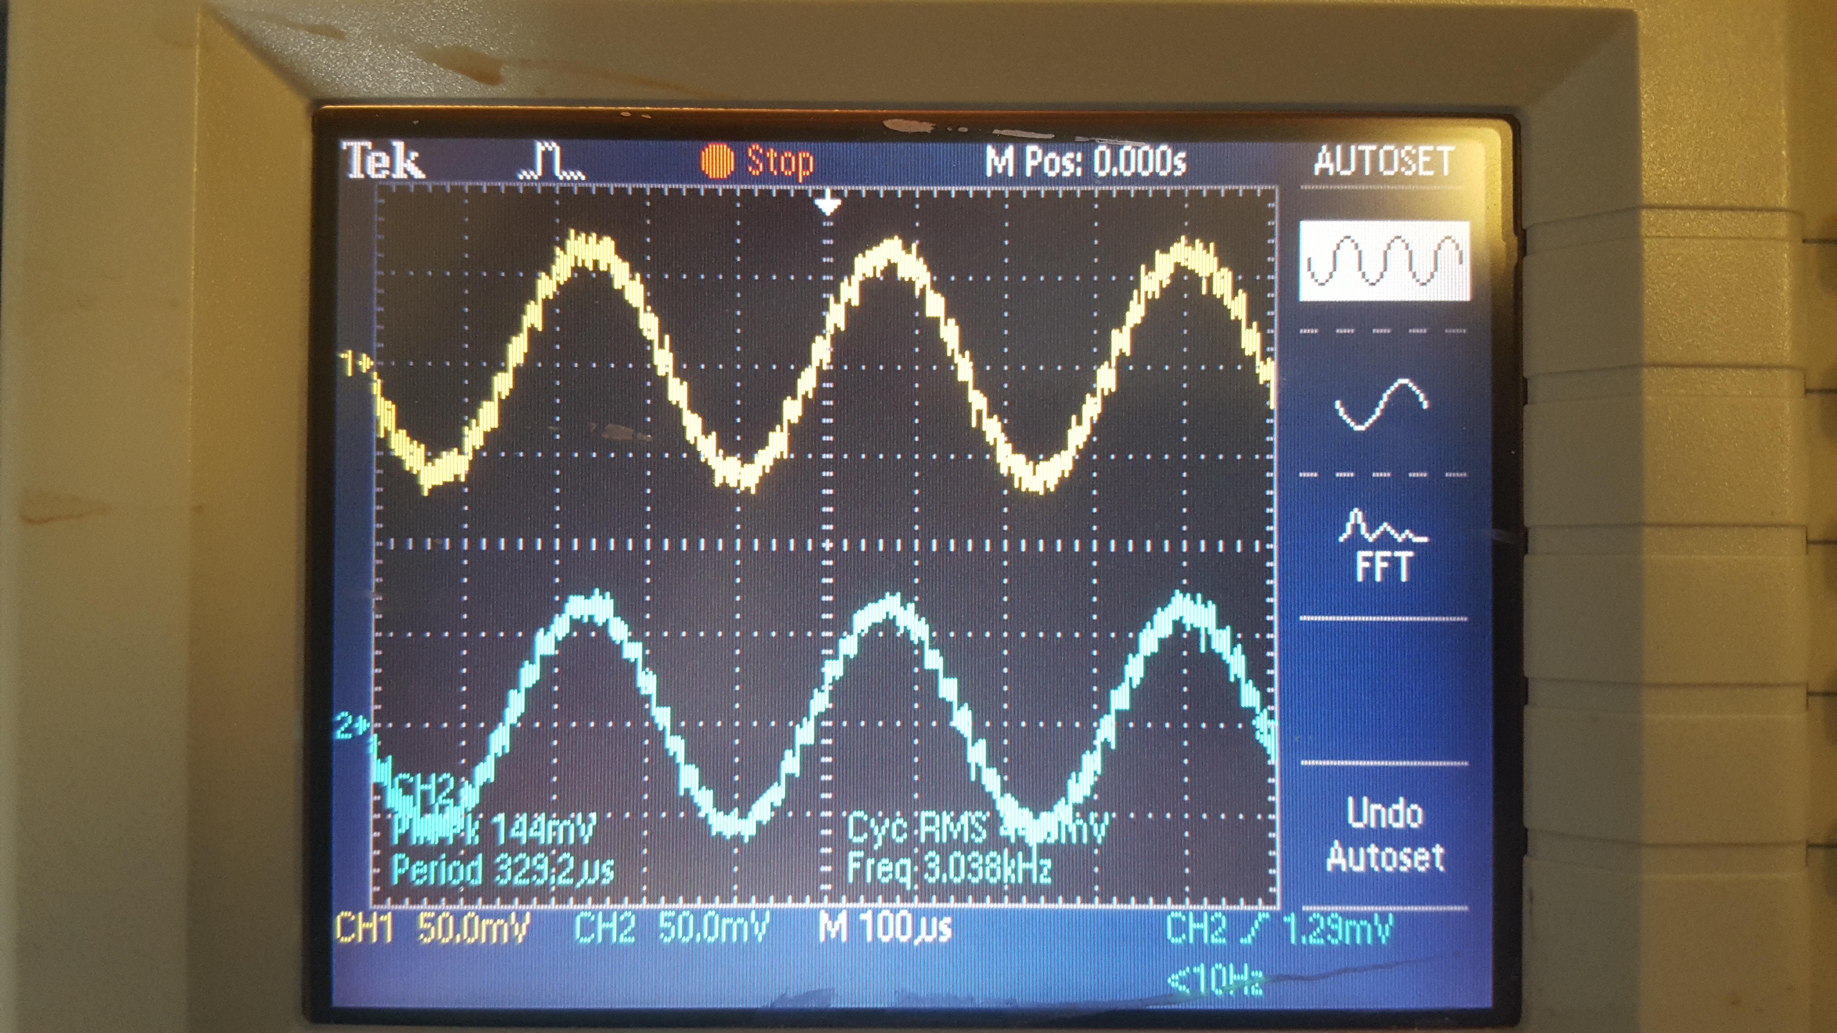

Figure Shows the stereo 3k input tone outputted by the dac

## 6k Hz Tone Results

Explan results and compare

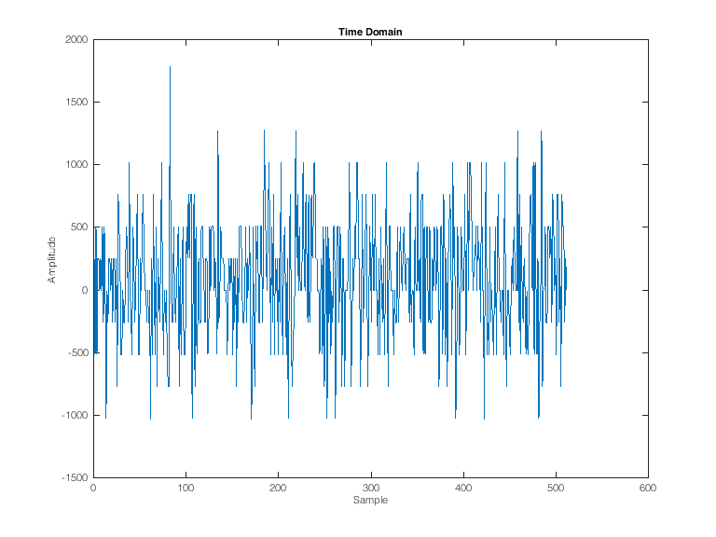

Figure 5 6k hz input tone sent over uart. Demonstrates aliasing due to high frequency input

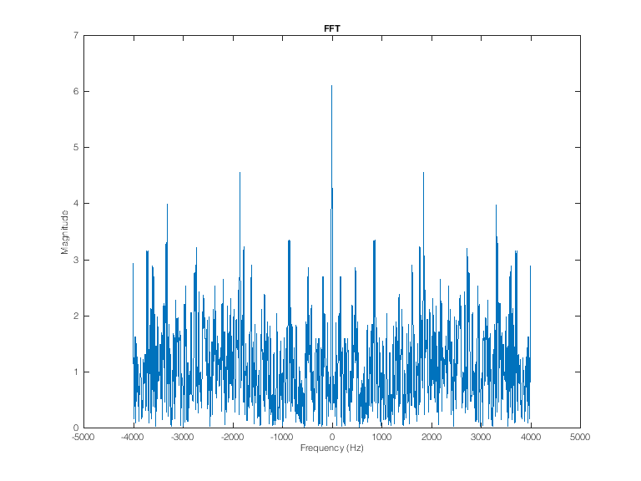

Figure 6 FFT of aliased 6 hz input signal

## C:\Users\Jake\Desktop\443\Labs\Lab_1\q2-6k.jpg

Figure A 6k input tone outputted from the dac

# Problem 3

Explain setup and code structure

## Example 1 [100011]

Explain what the parameters are

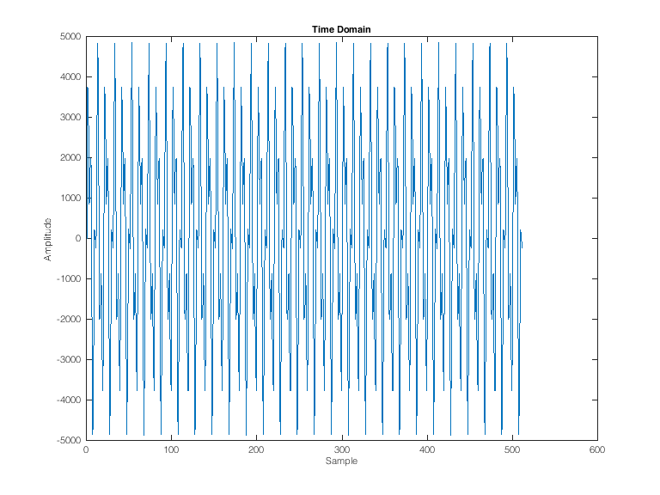

Figure

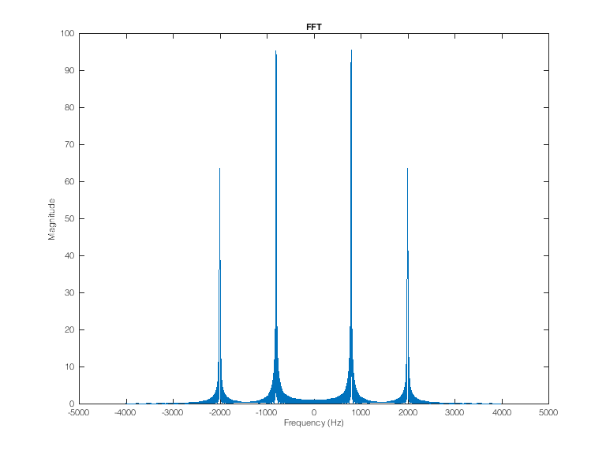

Figure

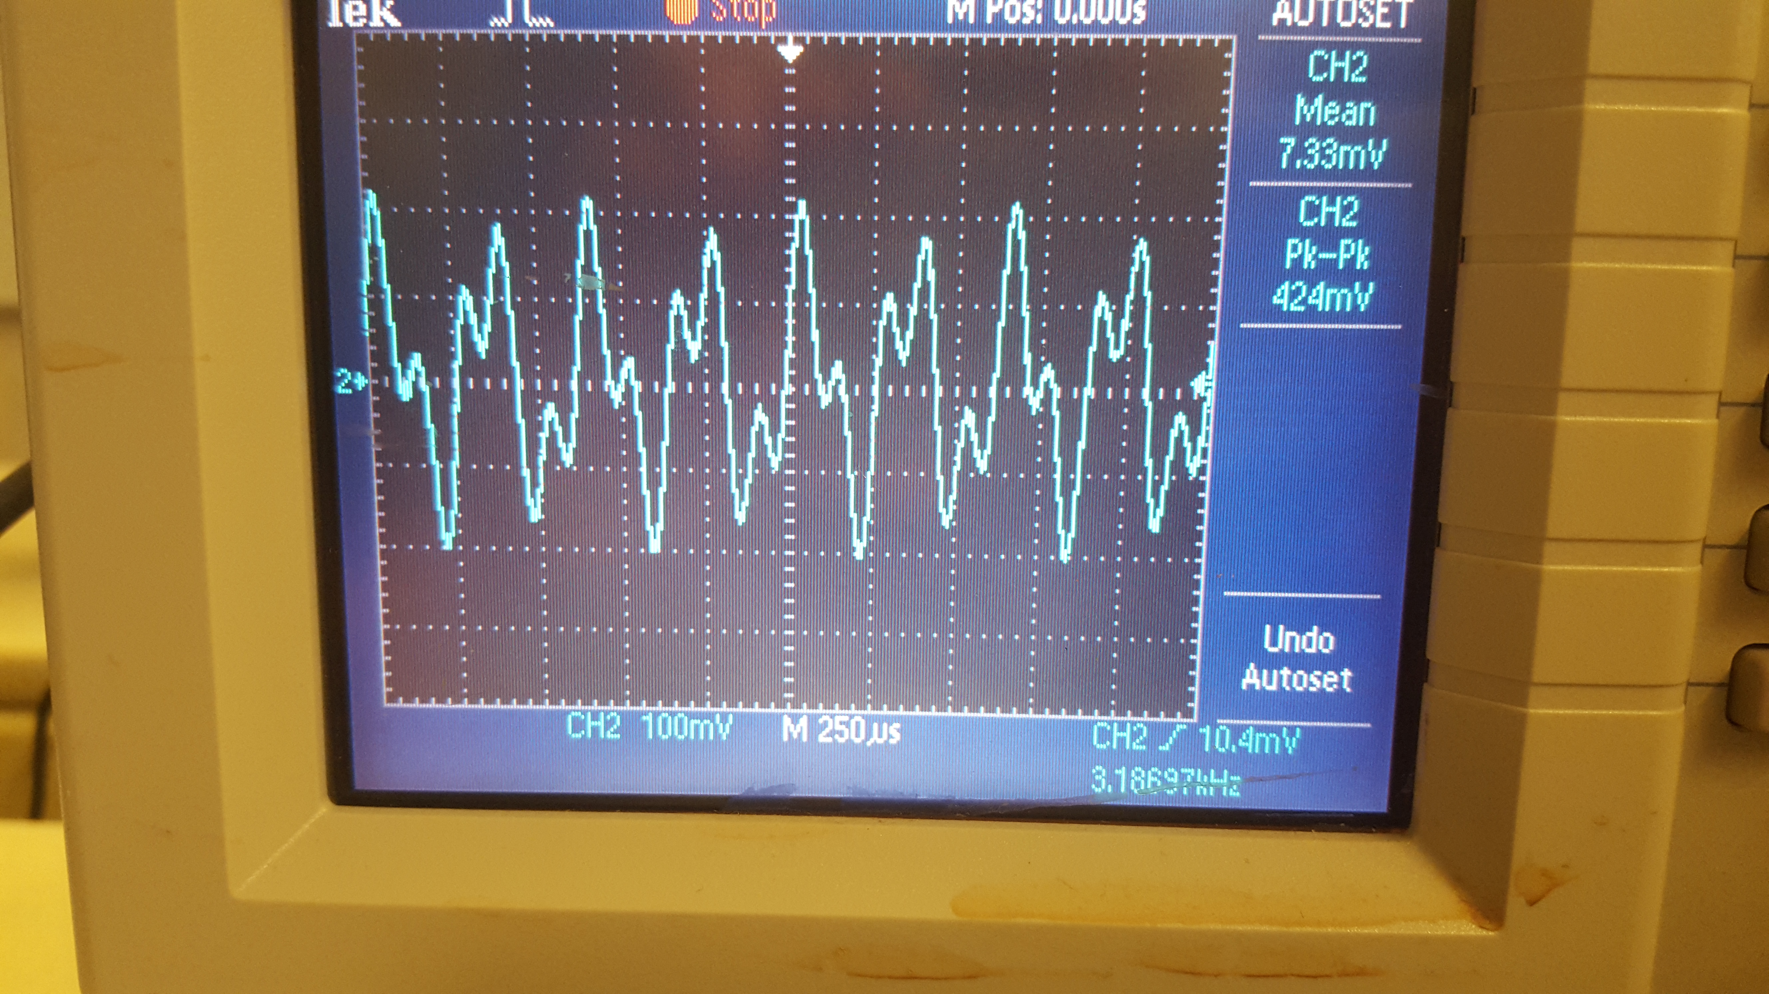

Figure

## Example 2 [100100]

Explain what the parameters are

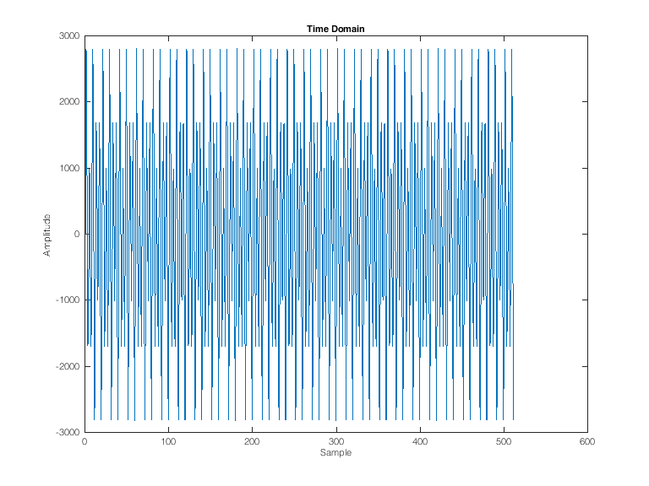

Figure

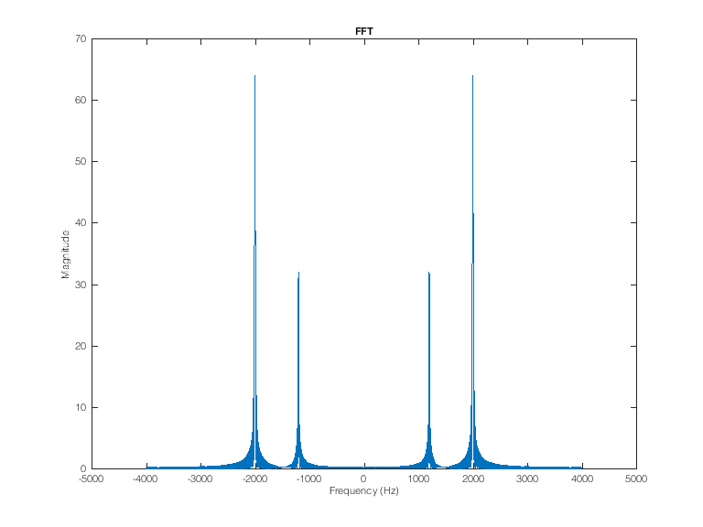

Figure

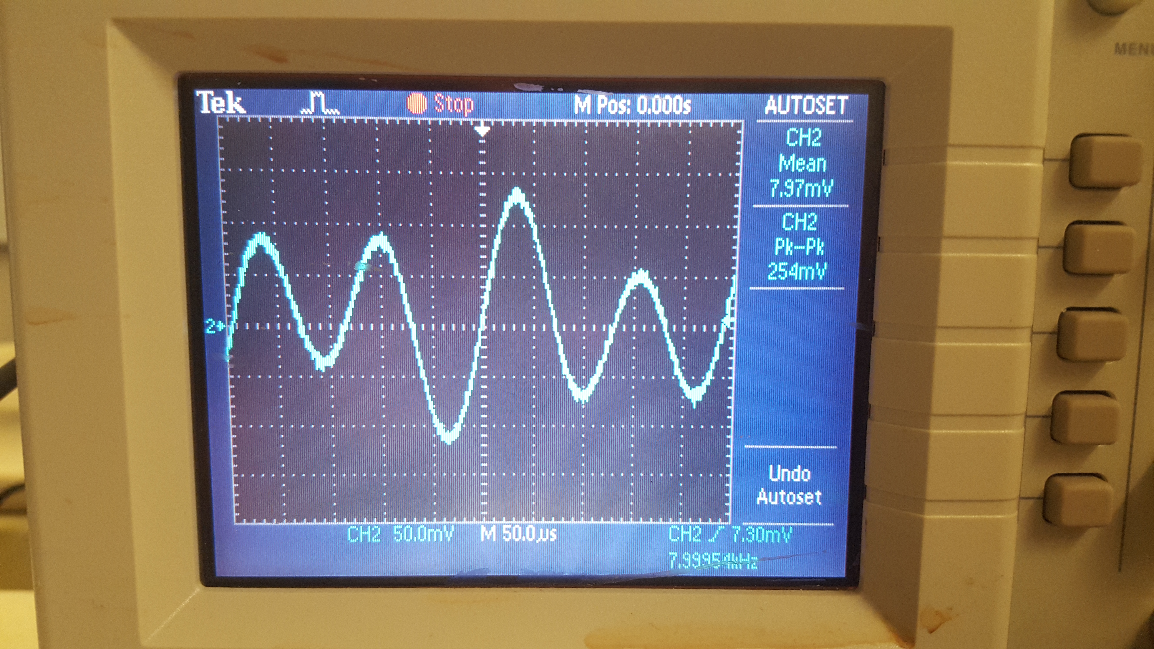

Figure

# Problem 4

Explain logic

# Problem 5

Explain logic